JOMO KENYATTA UNIVERSITY

OF

AGRICULTURE AND TECHNOLOGY



COURSE: BSc. COMPUTER TECHNOLOGY

PROJECT NAME: AI MOVIE RECOMMENDER SYSTEM

STUDENT NAME: CHRIS MUTUA

REGISTRATION NUMBER: SCT212-0063/2018

YEAR: 3RD YEAR



AI Movie Recommender System Design Document

15.04.2022

**─**

Chris Mutua

JKUAT

P.O. BOX 1764

JUJA

# Acknowledgment

I express my profound gratitude and deep respect to my supervisor Mr. Isaiah Mulang’ for his guidance, monitoring, and constant encouragement throughout this project. The help and guidance given by him from time to time have been a great help to me. I thank my classmates and friends for their support and constructive criticism that has improved my project immensely. Last but not the least, I thank my God for the gift of a sound and creative mind, good health and grace, my parents and brothers for their constant encouragement without which this assignment would not be possible.

# Abstract

Since the closure of most physical movie shops and the invention and innovation of existing technologies to support online media, the growth of internet service companies has greatly increased. This led to the emergence of movie companies such as Netflix, Hulu, Disney plus among many others. Cinemas have also increased in cities since the introduction of high-resolution displays and Hifi sound systems. This has led to the emergence of a need, that is on customers' side to determine the best movie to watch next that relates to certain categories and also get recommendations to their liking. This project is built to solve this need to reduce the stress of trying to find related movies to the current one. It covers a broad spectrum and uses Artificial Intelligence to make the process much more flexible and quicker based on a given updated database.

# Table Of Contents

I. Acknowledgement 2

II. Abstract 3

III. Table Of Contents 4

1 Introduction 8

1.1 Background Study 8

1.2 Problem Statement 8

1.3 Solution 8

1.4 Justification 9

1.5 Objectives 9

1.5.1 Main Objectives 9

1.5.2 Specific Objectives 9

1.6 Research Questions 9

1.7 Research Methods and Design 10

1.8 Scope 10

1.9 Schedule 10

1.10 Budget 11

2 Literature Review 13

2.1 Introduction 13

2.2 Components of a recommender system 13

IV. Data and recommender systems: These include the following: - 13

IV.1 User Behavior Data: User’s behavior data is useful information about the engagement of the user on the product. It can be collected from ratings, clicks and purchase history. 13

IV.2 User Demographic Data: User demographic information is related to the user’s personal information. 13

IV.3 Product Attribute Data: Product attribute data is information related to the product itself. 13

V. Relationships: These include the following: - 14

V.1 User-Product Relationship: This relationship occurs when some users have an affinity or preference towards specific products that they need. 14

V.2 Product-Product Relationship: These are relationships that occur when items are similar, either by appearance or description. 14

V.3 User-User Relationship: These are relationships that occur when some customers have similar tastes concerning a particular product or service. 14

2.3 How data is provided to the system 14

2.3.1 Rating 14

2.3.1.1 Explicit Ratings 14

2.3.1.2 Implicit Ratings 15

2.3.2 Filtering 15

2.3.2.1 Product Similarity (Item-Item Filtering) 15

2.3.2.2 User Similarity (User-User Filtering) 16

2.4 Types of Recommender Systems 16

2.4.1 Collaborative filtering 16

2.4.2 Content-based filtering 16

2.4.3 Multi-criteria recommender systems 17

2.4.4 Mobile recommender systems 17

2.4.5 Hybrid recommender systems 18

2.5 Benefits of recommender systems 18

2.6 System’s Workings 19

**2.7** Conclusion 25

3 System Analysis 26

**3.1** Introduction 26

3.2 Methodology 26

**3.3** Feasibility Study 27

3.3.1 Technical Feasibility 27

3.3.2 Economic Feasibility 27

3.3.3 Social Feasibility 28

3.3.4 Legal Feasibility 28

3.4 Requirements Engineering 29

3.4.1 Data Collection Methods 29

3.4.1.1 Questionnaires 29

3.4.1.2 Surveys 29

3.4.2 Functional and Non-functional Requirements 29

3.4.2.1 Functional Requirements 30

3.4.2.2 Non-Functional Requirements 30

3.4.3 Hardware and Software requirements 32

3.4.3.1 Hardware Requirements 32

3.4.3.2 Software Requirements 32

4 System Design 33

**4.1** Architectural Design 33

4.2 Specific case Database 33

4.3 Object Identification 33

4.4 Design Model 34

4.4.1 Use Case Diagram 34

4.5 User Interface 36

4.6 User Interface Design 36

1. Landing Webpage 36

2. Results Webpage 38

Goals and Milestones 39

Timeline 40

Conclusion 41

VI. Source Code Documentation 42

VII. Project Structure 42

VII.1 Contents 43

VIII. Project Setup and Configuration 45

IX. Project Setup and Configuration Run and Access the Project 47

X. Project UI Appearance 47

X.1 Main Page 47

X.2 Recommendations Webpage 48

X.3 User Interface Design 57

XI. Help and Maintenance 58

XII. References 59

# Introduction

## Background Study

The Internet, the backbone of the current worldwide revolution, has made entertainment much easier to achieve anywhere. This is because it has gone hand in hand with technological advancement to support cloud services that are profitable both to clients and organizations. The clients do need not much money to spend on expensive hardware and software to host the services and also, they can access it using the Just in time methodology during needs. Organizations can expand their services to a regional and global scope with little capital and effort. However, though the clients can access movies from their home screens, there is a great need to determine which movie is best fitted to them based on one’s history. This has led to the emergence of recommender systems that use a dataset to create relationships to the movie in history and generate a list of movies similar to that using AI. The recommender systems are very efficient and their results yield much expected results hence much profit. For this reason, they have been integrated with various sectors of different industries such as in ecommerce apps, managerial departments in companies, and even in the military during warfare.

## Problem Statement

Online Movie hosting services make a profit when people spend their time watching their content online. Clients on the other hand can by no means stay in a site for so long if they can’t find movies that are captivating to them, each having their different desires. Clients hate long scrolling to find their expected results. New users pose another challenge for the companies since they might lack a history in the companies’ history database. Companies, therefore, focus on systems that will solve all these problems as well as add additional value to them while still being cheap in terms of hosting and maintenance.

## Solution

The recommender system creates great relationships to the movies in the dataset given and produces wide recommendations for users. To reduce scrolling time and increase view time, companies integrate recommender systems into their systems to ease the process and solve the problem.

The recommender systems continue evolving on their own based on constant users’ feedback to the system hence increasing their flexibility as well as requiring less maintenance. This adds value to the company’s profit. Users will spend less time on searches since the next movie suggestion is intriguing to them. Results will be more watch time and entertainment to the users as well as more profit to companies. Users can also be aware of similar movies to one they saw in places lacking their histories such as in theaters or cinemas.

## Justification

The movie recommender system benefits will include:

* Less search time of similar movies to users
* More watch time hence more profit to users
* Clients can find additional information about the movies being searched for to influence their decision on which to watch. This prevents viewing of immoral content to users below a certain age
* It is a simple to use a mechanism that makes it user friendly for a user

## Objectives

### Main Objectives

The main objective is to create an AI movie recommender that can be used as a stand-alone system or integrated into a current movie hosting system yet flexible based on feedback and updates in the dataset provided.

### Specific Objectives

* Analyze movie dataset for similar patterns and relationships
* Produce a list of related movies based on several factors such as directors, cast, year of release, rating, and category among many others.
* Be flexible based on the updates to the database for current results.

## Research Questions

What is a Recommender System?

How does it get integrated into the current technologies both hardware and software?

What pros and cons are given by the AI system?

How does it get integrated into the existing information systems?

What are the risks of the system?

## Research Methods and Design

To collect data to be used in this project, a quantitative research approach will be used. Some of the participants in this method will include clients and some of the companies. Various data collection methods to be in use will include online surveys, paper surveys, mobile surveys, face-to-face interviews, telephone interviews, online polls, and systematic observations. The quantitative data collection method will have the following pros:

* Allow gathering information from a relatively large number of participants
* Can survey several groups, allowing for comparison
* This leads to statistical techniques that allow determining relations between variables

## Scope

The project will cover a wide global range since most of the movie companies and theaters are well distributed worldwide. Clients also are globally located and access most of these kinds of services remotely.

## Schedule

The project is scheduled to take one semester. Below is an activity breakdown to be performed during this period. The project Schedule is shown in Table 1 below:

| Task Id | Task Name | Expected Start Date | Expected End Date | Deliverables |
| --- | --- | --- | --- | --- |
| 1 | Project Idea | 1st Oct | 3rd Oct | Draft Proposal |
| 2 | Project proposal Writing | 3rd Oct | 5th Oct | Final Proposal |
| 3 | Literature Review Writing | 6th Oct | 7th Oct | Literature Review Report |
| 4 | Methodology Writing | 8th Oct | 9th Oct | Project Model |
| 5 | System Implementation and Presentation | 10th Oct | 17th Dec | Complete Working Project |
| 6 | Project Documentation | 18th Dec | 20th Dec | Compiled Project Documentation |
| 7 | Final Project Presentation | 21st Dec | 22nd Dec | System and Documentation Presentation |

*Table 1: Schedule*

## Budget

The project’s budgetUser is as shown below:

| Id | Description | Cost (Kenyan Shillings) |
| --- | --- | --- |
| 1 | Internet Bundles | 5000 |
| 2 | Printing and bidding | 1200 |
| 3 | CD and burning cost | 200 |
| 4 | Research Cost | 5000 |
| Totals | | **11400** |

*Table 2: Budget*

# Literature Review

## Introduction

Recommender systems are machine learning systems that help users discover new products and services. Every time you shop online, a recommendation system is guiding you towards the most likely product you might purchase.

Recommender systems are an essential feature in our digital world, as users are often overwhelmed by choice and need help finding what they're looking for. This leads to happier customers and, of course, more sales. Recommender systems are like salesmen who know, based on your history and preferences, what you like.

These systems are so commonplace now that many of us use them without even knowing it. Because we can't possibly look through all the products or content on a website, a recommendation system plays an important role in helping us have a better user experience, while also exposing us to more items we might not discover otherwise.

Some examples of recommender systems in action include product recommendations on Amazon, Netflix suggestions for movies and TV shows in your feed, recommended videos on YouTube, music on Spotify, the Facebook newsfeed, and Google Ads.

## Components of a recommender system

A recommender system may be composed of any or all of the following three components:

1. **Data and recommender systems:**

These include the following: -

1. User Behavior Data: User’s behavior data is useful information about the engagement of the user on the product. It can be collected from ratings, clicks, and purchase history.
2. User Demographic Data: User demographic information is related to the user’s personal information.
3. Product Attribute Data: Product attribute data is information related to the product itself.
4. **Relationships:**

These include the following: -

1. User-Product Relationship: This relationship occurs when some users have an affinity or preference towards specific products that they need.
2. Product-Product Relationship: These are relationships that occur when items are similar, either by appearance or description.
3. User-User Relationship: These are relationships that occur when some customers have similar tastes concerning a particular product or service.

Inside recommender systems, there are the following:

* Candidate generations
* Scoring systems
* Scoring systems
* Re-ranking systems

1. **Candidate generations**: This component decomposes the huge pool of candidates (potential recommendations) into smaller subsets. It then recommends these small subsets to the online user.
2. **Scoring systems**: The scoring system allocates a score to all the items or elements in the subsets.
3. **Re-ranking systems**: These systems consider the item scores and other constraints to generate the final rankings.

## How data is provided to the system

### Rating

Data can be provided in a variety of ways. There are two particularly important methods, explicit and implicit rating.

#### Explicit Ratings

Explicit ratings are provided by the user. They infer the user’s preference. Examples include star ratings, reviews, feedback, likes, and following. Since users don't always rate products, explicit ratings can be hard to get.

#### Implicit Ratings

Implicit ratings are provided when users interact with the item. They infer a user’s behavior and are easy to get as users are subconsciously clicking. Examples include clicks, views, a budget user, purchases. (Note: Views and purchases can be a better entity to recommend as users will have spent time and money on what is most crucial for them.)

### Filtering

This can be created by using similarity measures. The similarity is measured using the distance metric. The nearest points are the most similar and the farthest points are the least relevant. The similarity is subjective and is highly dependent on the domain and application. For example, two movies are similar because of genre length or cast. Care should be taken when calculating distance across dimensions/features that are unrelated. The relative values of each element must be normalized, or one feature could end up dominating the distance calculation.

Some of these calculations can be carried out using the following formulas:

* Minkowski Distance
* Manhattan Distance
* Euclidean Distance
* Cosine Similarity
* Pearson Coefficient
* Jaccard Similarity
* Hamming Distance

#### Product Similarity (Item-Item Filtering)

This is the most useful system for suggesting products based on how much the user would like the product. If the user is browsing or searching for a particular product, they can be shown similar products. Users often expect to find products they want quickly and move on if they have a hard time finding the relevant product. When the user clicks on one product, we can show another similar product, or if the user buys the product, we can email the user advertisements or coupons based on a similar product. Product similarity is particularly useful when we don’t know much about the user yet, but we do know what products they're viewing.

#### User Similarity (User-User Filtering)

User similarity is for checking the difference between the similarities of two users. If two users have similar preferences for a product, we can assume they have similar interests. It’s like a friend recommending a product.

One shortcoming of user similarity, however, is that it requires all the user data to suggest products. It’s called a cold start problem because beginning the recommendation process requires previous data from users. A newly launched e-commerce website, for example, suffers from the cold start problem because it doesn't have a large number of users.

Product similarity doesn’t have this problem because it just requires product information and the user’s preference. Netflix, for example, avoids this issue by asking users their likes when starting a new subscription.

## Types of Recommender Systems

The following are the main types of recommender systems:

* Collaborative filtering
* Content-based filtering
* Multi-criteria recommender systems
* Mobile recommender systems
* Hybrid recommender systems

### Collaborative filtering

This type of recommender system uses the rating profile of users to generate recommendations. It also uses the feedback and reactions of past users to suggest products to other users.

Collaborative filtering consists of two approaches: the memory-based approach and the model-based approach. The memory-based approach suggests items based on similar user interaction profiles or similar items that the user has interacted with. The model-based approach uses information relating to the user-item interactions to generate a latent model for recommendation.

### Content-based filtering

This type of recommender system uses the additional details of items and users to generate suggestions for items. For example, a recommender system for a movie may analyze additional information such as the main actors and the duration of the movie.

This system can also analyze information such as the sex or age of the users that watched the movie. This collective information will be used to suggest movies based on the profile of the user (sex or age).

### Multi-criteria recommender systems

These systems provide recommendations based on multiple criteria relating to preference information. The system analyzes the preference information of a user for an explored item using various criteria, rather than a single criterion. It then forecasts a rank for unexplored products and provides relevant suggestions to the user.

### Mobile recommender systems

These systems use smartphone devices to offer personalized recommendations. The accuracy of these systems depends on the context, privacy, and recommendation approach. A good example of a mobile recommender system is the one used by taxi companies such as Lyft, DiDi, and Uber.

In such a case, the system uses the GPS information of routes used by drivers to recommend appropriate pick-up points. The GPS information used includes the operational status, location, and time stamps.

### Hybrid recommender systems

Hybrid recommender systems combine content-based filtering and collaborative filtering approaches. These systems help in overcoming some of the limitations of pure recommender systems such as sparsity problems and cold start.

Data sparsity makes it difficult for the system to find similar users because the active users rated a few numbers of products or items. The cold start problem occurs when the system finds it difficult to provide accurate suggestions because there is insufficient information about users.

Netflix is an example of a company that employs hybrid recommender systems.

## Benefits of recommender systems

Recommender systems offer the following benefits:

1. **Drive traffic**: They provide an effective way of driving traffic to your website, especially through targeted blasts.
2. **Improved user experience**: Recommender systems enable users to locate the desired products through appropriate item suggestions. This improves the user experience, which is an important factor that helps to retain customers.
3. **Reduced workload**: These systems automate the process of analyzing the online behavior of all customers. This reduces the workload that would be required if the shopping experience of every customer is analyzed manually by the IT experts.
4. **Increased revenue**: Increased traffic, customer retention, and personalized experiences translate to increased sales revenue. Improved engagement with potential buyers transforms many of them into actual and repeat buyers.

**NOTE: -** As for this project, *product attribute data* and *product-product relationship* will be used for the system so that time deadlines might be met and also be functional. It will produce results based on the products (those are the movies), attributes (titles, genre, ratings, date, and casts among many others) and their relationships between the products and attributes.

## System’s Workings

The system first recognizes the items that are subject to the system, their attributes, and any other additional items relating to the system. It then notes them down and lists them in the form of a tabular format. In this case, the subject of the system are movies that have the following attributes that can be used to make relationships between the items:

* Name
* Date of release
* Genre
* Casts
* Director
* Ratings such as the IMDB ratings
* Series or the movie sequel number

In case 5 items are being evaluated, it will try to relate the five side by side thus creating a complex relationship between them.

For instance, if it will be focusing on an attribute such as the *Date of release*, where the movies’ dates of release are as shown below:

| Movie (Represented by item number) | Date of release (by year) |
| --- | --- |
| Item 1 | 2005 |
| Item 2 | 2010 |
| Item 3 | 2001 |
| Item 4 | 1999 |
| Item 5 | 2001 |

*Table 3: Movies by their Dates of release*

it will arrange them as shown in the table below:

| Movies (Represented by Items) | Item 1 | Item 2 | Item 3 | Item 4 | Item 5 |
| --- | --- | --- | --- | --- | --- |
| Item 1 | - | X | X | X | X |
| Item 2 | X | - | X | X | X |
| Item 3 | X | X | - | X | ✓ |
| Item 4 | X | X | X | - | X |
| Item 5 | X | X | ✓ | X | - |

*Table 4: Movies Relationships based on their Dates of Release*

As shown, the movies can relate to each other based on the dates of release. In this case, movies represented by ***Item 3*** and ***Item 5*** relate since they were all released in ***2001.*** Hence, when Item 3 is searched for, Item 5 would be recommended first.

There can also be another relationship generated based on how close the release dates are to other release dates. For instance, 2001 is closer to 1999 than 2005. Hence, when Item 3 is searched for, the system can also recommend Item 4 adjacent to Item 5, followed by Item 1and lastly Item 2.

The above can be easily shown in the table below:

| Movie (by Item number) | Number of years margin between it and Movie represented by Item 3 |
| --- | --- |
| Item 1 | 4 |
| Item 2 | 9 |
| Item 3 | - |
| Item 4 | 2 |
| Item 5 | 0 |

*Table 5: Items relationship by Margins in their Dates of Release*

The system then does for all the other movies in the dataset using the above pattern to create great lengths of relationships.

Let’s consider another attribute such as the *Genre.*

If the movies mentioned above lie in the following Movie Genres:

| Movie (by Item number) | Genres |
| --- | --- |
| Item 1 | Action |
| Item 2 | Comedy |
| Item 3 | Dance |
| Item 4 | Horror |
| Item 5 | Thriller |

*Table 6: Movies and their Genres*

Since most viewers of Genres such as Comedy prefer to view a Genre such as Dance than viewing those of Action, Horror, and Thriller Genres; then the system will recommend them over the latter.

If a user searches for a movie that is under the Thriller Genre, that means that the same user can likely view an Action and a Thriller movie over Dance and Comedy movies.

If the relationships are classified in terms of percentages, then their relationships will be as shown below:

| Movie (by Item number) | Item 1 | Item 2 | Item 3 | Item 4 | Item 5 |
| --- | --- | --- | --- | --- | --- |
| Item 1 | - | 40 | 25 | 25 | 30 |
| Item 2 | 40 | - | 60 | 20 | 40 |
| Item 3 | 25 | 60 | - | 10 | 15 |
| Item 4 | 25 | 20 | 10 | - | 60 |
| Item 5 | 30 | 40 | 15 | 60 | - |

*Table 7: Movies by Genre ratings (In percentage %)*

Considering the Rating attribute, if the movies have the following ratings:

| Movie (by Item number) | Ratings (out of 10) |
| --- | --- |
| Item 1 | 7.5 |
| Item 2 | 8.0 |
| Item 3 | 5.0 |
| Item 4 | 6.5 |
| Item 5 | 9.0 |

*Table 8: Movie by Ratings*

If the user searches for a movie represented by Item 4, then the system can be able to create the relationship between it and the rest in the dataset as shown by the table below which creates them by the differences in the ratings (as shown in the table above):

| Movies (by Item number) | Item 1 | Item 2 | Item 3 | Item 4 | Item 5 |
| --- | --- | --- | --- | --- | --- |
| Item 1 | - | 0.5 | 2.5 | 1.5 | 1.5 |
| Item 2 | 0.5 | - | 3.0 | 1.5 | 1.0 |
| Item 3 | 2.5 | 3.0 | - | 1.5 | 4.0 |
| Item 4 | 1.5 | 1.5 | 1.5 | - | 2.5 |
| Item 5 | 1.5 | 1.0 | 4.0 | 2.5 | - |

*Table 9: Movies relationships by Rating Differences*

Based on the table above, when one searches for Item 3, the system will recommend the movies in the order below:

* Item 4
* Item 1
* Item 2
* Item5

Considering the casts and the directors, the same will be done. As for the actor’s side, the system searches for movies in which most of its actors are in the one searched for. The recommended one will probably have the same features as the ones they did last.

The probability of movie directors working on related projects is high, so the probability of the movies being liked by the viewers is high. Thus, the recommender will be effective.

**Final Step**

Now, the AI creates extremely diverse and complex relationships between each item and the others in the dataset which would have in turn been extremely complex and resource-heavy for mathematically built systems since the amount of computing power needed is great.

After the system makes relationships in different attributes, the recommender calculates the best relationship by the combination of all the attributes.

For instance, if the Movie represented by Item 3 has the following ratings to the other movies in the dataset on each of the attributes shown below:

| Movie (by Item number) | Name | Date of Release (By years) | Genre | Casts | Directors | Ratings | Totals (out of 600%) | Rankings |
| --- | --- | --- | --- | --- | --- | --- | --- | --- |
| Item 1 | 50 | 20 | 20 | 10 | 100 | 50 | 250 | 2 |
| Item 2 | 20 | 50 | 60 | 5 | 0 | 90 | 225 | 4 |
| Item 3 | - | - | - | - | - | - | - | - |
| Item 4 | 70 | 50 | 40 | 60 | 0 | 10 | 230 | 3 |
| Item 5 | 60 | 90 | 15 | 20 | 100 | 60 | 345 | 1 |

*Table 10: Movies Rankings by Attributes*

In which the above data represents how likely out of a hundred percent the system will recommend the movie based on the attribute searched for, then when the total is calculated, the top movie will be most likely recommended.

In the above table, when one searches for a movie represented by Item 3, then the system will produce an output in the order below:

* Item 5
* Item 1
* Item 4
* Item 2

## Conclusion

The AI system considers all attributes hence gives out the best output than those of mathematical systems.

# System Analysis

## Introduction

In system analysis, I interacted with the user of the system to find out the user requirements and analyze the system to understand the functionality. The system analysis was mainly based on what the system was required to do. System analysis was performed to identify the following;

* The scope of the system in terms of system functionalities and non-functional requirements.
* Information that was to be included in the system to enhance faster delivery of services.

## Methodology

The methodology that will be used in implementing the Location-Aware Company Contacts Searching System is Object-Oriented Analysis and Design (OOAD) that will be performed within the Unified Software Development Process (USDP). This methodology is suitable because of its object-oriented approach to solving problems as well as its iterative nature which allows smooth transitions between stages that are well incorporated with the flow of the development of the system. Also, the reuse of code is easy and faster and training is readily available in that an online version of USDP walks users through the process in a step-by-step tutorial manner. Unified Software Development Process incorporates four phases which are: -

1. **The inception phase**- developers define the scope of the project and its business case. The elaboration phase- developers analyze the project’s needs in greater detail and define its architectural foundation.
2. **The construction phase**- developers create the application design and source code.
3. **The transition phase** - developers deliver the system to users. RUP provides a prototype after each iteration phase.

## Feasibility Study

This is a study aimed at finding out whether the system is viable or not, carried out to make sure that the new system would be efficient to the users once implemented. It is concerned with analyzing the available technology, system operation, and use of the available funds for the project. The feasibility study was done during several visits to companies and interviewing several students who are potential users of the system to find out how they got company contacts information. A feasibility study was carried out on the following areas to determine the viability of the project.

### Technical Feasibility

According to the current technological advancement, the growth in processing power and speed and the advancement in technology and networking facilities can facilitate the system at ease.

Below is a table showing the required technical capabilities to facilitate 10,000 requests to the system per second:

| Capability | Specs |
| --- | --- |
| Processing power | Octa-core of 4.0GHz base frequency |
| RAM | 64 GB |
| Storage space | 250 GB SSD |
| Network Card | 10 Gbps |

*Table 11: Server Unit Specs per unit*

When the staff was consulted, the response out of 100 who were questioned, 87 accepted the above recommendations.

With the majority of the staff approving the system as technically viable, its development was approved.

### Economic Feasibility

Since there has been continuous development in hardware and services, the cost has greatly declined.

Economic feasibility carried is as shown below:

| Item | Cost (in KSh.) |
| --- | --- |
| 10 Servers | 5,000,000 |
| Network Devices | 1,000,000 |
| Software installation and integration | 800,000 |
| Software training and maintenance | 200,000 |
| Software cost | 1,000,000 |
| Total | 8,000,000 |

*Table 12: Cost of the System*

### Social Feasibility

This was based on the acceptability of the system by users. It dealt with the willingness and ability of smartphone users to accept the proposed application. While some respondents thought this wouldn’t change anything in their way of doing things, many agreed that it is very hectic to get company contacts either to make a general inquiry, place an order, or request an internship. Below is a table of the results collected from the survey.

| View | Percentage of Respondents answers (%) |
| --- | --- |
| The system will be helpful | 73 |
| The system will not be helpful | 20 |
| Not Sure | 4 |
| Unanswered | 3 |
| TOTALS | 100 |

*Table 13: Views in Percentage*

### Legal Feasibility

This study method was carried out to find out whether the new system abides by the laws, rules, and regulations, which should not be violated. Some of the applications that could be used in developing the application needed licenses from the legal owners and this are these to be adhered to during the development of the application.

## Requirements Engineering

### Data Collection Methods

To properly assess the appropriate requirements for the system, the below technique was used for collecting information.

#### Questionnaires

Questionnaires were distributed via email and the link to the online survey was posted on social media platforms for instance Facebook. (See questionnaire and the responses at the Appendix)

#### Surveys

Eye surveys were also preferred because of their simplicity and quick outcomes.

### Functional and Non-functional Requirements

An in-depth analysis of data collected from multiple and various stakeholders in the proposed application revealed the following functional and non-functional changes portability, the easy-to-use requirements.

#### Functional Requirements

The system will be able to do the following once fully built, implemented, and deployed successively:

* Allow user requests and display the requests being made. This will enable simple tracking and follow-ups in case of errors and any complaints.
* Support input search autocomplete feature. This feature will minimize typing errors and also increase the searching speed since one won’t have to input the whole title if it already exists in the system.
* Fetch the connection between the title entered in the search bar and the ones in the datasets provided to it. Carry this out using the genre, title, directors, casts (actors), rating e.g., IMDB rating, and year among many other factors.
* Display the fetched results so that the user can easily choose their preference.
* In case of any errors, handle them with ease but also inform the end-user on how to proceed from them.
* Display additional information on the movie searched for such as reviewer comments which will help the user determine if the movie is appropriate for them.

#### Non-Functional Requirements

This refers to the look and the feeling of the application. It’s what the application should have, how it should look and how it should feel like when working with.

These include:

1. **Efficiency**-The application ensures efficient (i.e., no wasteful use) of resources available such as memory, processor and disk space. It will also include the general performance of the application.
2. **Usability**-The application allows users to accomplish their tasks with minimum time. It is easy to learn and use. To enhance its usability, the application will have a friendly user interface, easy to use navigational tools, and a “Help” option that users may click to get more information.
3. **Portability**-The application will have the capability to be run on different android devices.
4. **Maintainability**-The application is flexible to meet future modifications over its lifetime without incurring costs and/or consuming time. This is caused by change in technology, and user needs.
5. **Interoperability**-The application is in a position to co-exist with other applications in the android environment.

### Hardware and Software requirements

These are the hardware and software requirements needed to successfully develop the application.

#### Hardware Requirements

For a small-scale demonstration and running of the system, the following will be the requirement:

* Laptop Computer with the following minimum requirements:
  + 500GB hard disk
  + 8GB RAM
  + 2.3GHz Quad-core Processor
  + An Android Test device
  + 16GB flash Disk or External Hard Disk.
* Desktop Computer with the following minimum requirements:
  + 500GB hard disk
  + 4GB RAM
  + 2.3GHz Dual-core Processor
  + An Android Test device
  + 16GB flash Disk or External Hard Disk.

#### Software Requirements

* PyCharm IDE
* Android Studio for a phone simulation

# System Design

System design looks at how data will be captured and entered into the application for processing. This is through designing use cases and collaboration diagrams that depict how the users will interact with the proposed application. It also looks into how the data will be output after processing. A design specification was produced that was in line with the defined user requirements which had been specified during the system analysis. The purpose of this section is to outline the architecture and general system outlay of the Location-Aware Company Contacts Searching Application and to describe and identify key contents.

## Architectural Design

The components for this system were selected based on the information gathered. System architectural design facilitates the selection of suitable hardware and software solutions based upon the needs of the users.

## Specific case Database

The Datasets used are as follows:

1. IMDB 5000 Movie Dataset
2. The Movies Dataset
3. List of movies in 2018
4. List of movies in 2019
5. List of movies in 2020

## Object Identification

The object classes identified were movies.

The object attributes identified include:

* Name
* Date of release
* Genre
* Casts
* Director
* Ratings such as the IMDB ratings
* Series or the movie sequel number

## Design Model

The design models showed the objects in a system and the different kinds of relationships between these entities. The design models are the bridge between the requirements for the system and the system implementation. They have to be abstract so that unnecessary detail does not hide the relationships between them and the system requirements. However, they also include enough detail for programmers to make implementation decisions.

The system can be represented by the following models:

1. Use Case Diagram

### Use Case Diagram

The main Actor who will interact with the system is the Client or the End-user. He/She will be able to perform requests to the system which then produces the desired outcome.

Below is what the Use case diagram looks like:

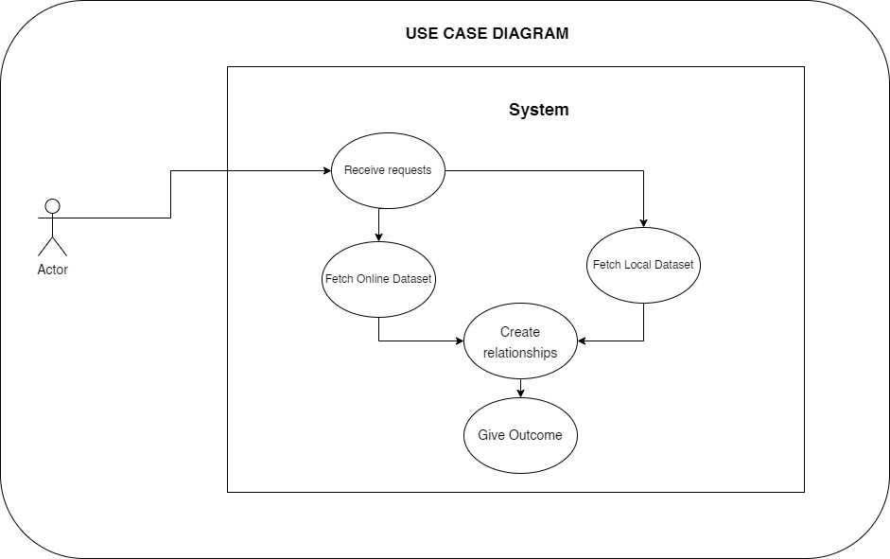

## User Interface

The following will have to be considered when building the site’s user interface:

* Consistency in design and color selections
* Simplicity in design
* Minimizing of errors
* Error handling and user-friendliness
* The minimalism of the site's content reduces three excessive uses of long-term memories especially for old users since it can be stressful for them.

## User Interface Design

The application will contain two main webpages, these are:

1. Landing webpage
2. Results webpage

The contents of these web pages are as discussed below:

### Landing Webpage

This is also known as the main web page since by default the application will use it as the landing page.

It shall contain the search bar which allows one to key in searches for the system to take in as input. It shall display autocomplete titles if they exist and are related to the search. One can click on them for a quick autocomplete feature.

It also displays errors such as if the system lacks the searched movie title.

It shall appear as shown below:

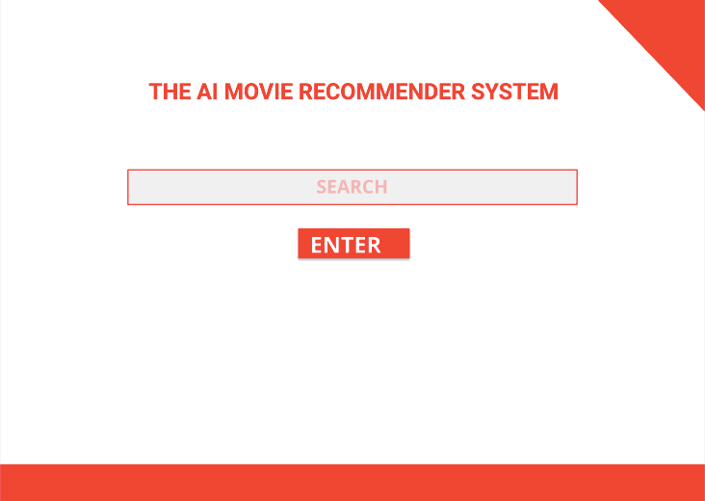

The site will display the following in case of any errors such as non-existent searches:

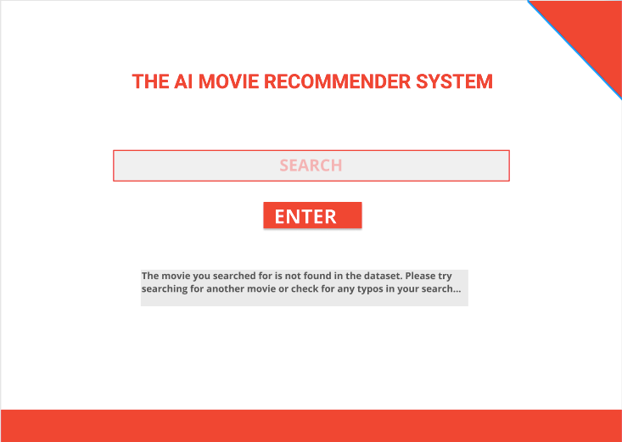

### Results Webpage

Whenever the user runs a successful search, the application will display the searched-for movie, its descriptions, reviews, and recommendations among other things. The design of this is shown in the image below:

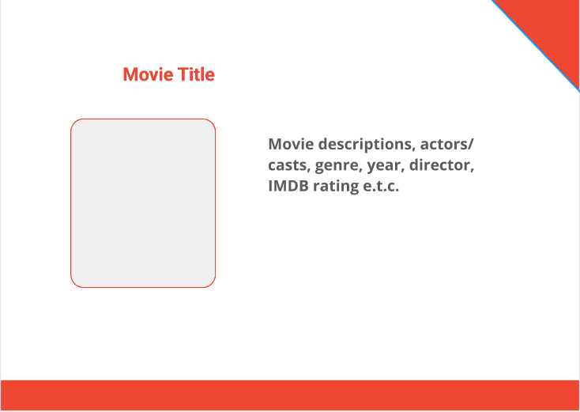

## Goals and Milestones

The following achievements will be able to show the progression of the application development process:

1. Creation of the Landing page and Results page web templates which will be used to generate static web pages that will have the fetched data in them
2. Create the Search Autocomplete feature
3. Create a connection between the application with the online dataset provided using the API and the API_KEY for recent and updated results
4. Create the AI engine to evaluate the datasets and display the results to best fit.
5. Document the system
6. Do tests using various data
7. Correct any minor errors and rerun tests
8. Do installations and deployments

## Timeline

The project will take approximately three months (3 months) to be completed.

The time will be split as follows:

| Dates | Days | Tasks | | | | | | | |
| --- | --- | --- | --- | --- | --- | --- | --- | --- | --- |
| 10/10/2021 to 11/10/2021 | 1 day | Creation of the web page templates |  |  |  |  |  |  |  |
| 12/10/2021 to 13/10/2021 | 1 day |  | Implementing Autocomplete feature |  |  |  |  |  |  |
| 14/10/2021 to 15/10/2021 | 1 day |  |  | Creating API connection with IMDB |  |  |  |  |  |
| 16/10/2021 to 05/11/2021 | 21 days |  |  |  | Create the AI engine |  |  |  |  |
| 06/11/2021 to 19/11/2021 | 14 days |  |  |  |  | Document the system |  |  |  |
| 20/11/2021 to 4/12/2021 | 14 days |  |  |  |  |  | Do system tests |  |  |
| 5/12/2021 to 12/12/2021 | 7 days |  |  |  |  |  |  | Correct errors and rerun tests |  |
| 13/12/2021 to 17/12/2021 | 4 days |  |  |  |  |  |  |  | Install and deploy the project |

## Conclusion

If the project is well developed within the speculated time, then the system will be very advantageous to the end-users who would like to get suggestions based on the ones which they have ever seen or that which they are interested in. It will have a well understandable structure that will facilitate developer contributions from other users.

Source Code Documentation

The application Software is made using Python, and the web pages are made using HTML and finally styled using some CSS.

**FLASK** web framework was used to develop the application in Python. This is because of its simplicity and its small size. This size makes it easy for one to handle the whole project quickly.

**The Source code is found in this GitHub repository:**

[https://github.com/RisoriTofa/AI-Movie-Recommender-System](https://github.com/RisoriTofa/AI-Movie-Recommender-System/blob/main/Documentation/Documentation.docx)

# Project Structure

The Project consists of the following folder and file structure:

* Datasets (folder)
* Documentations (folder)
* Screenshots (folder)
* Static (folder)
* Templates (folder)
* main_data.csv (file)
* main.py (file)
* nlp_model.pkl (file)
* Procfile (file)
* README.md (file)
* requirements.txt (file)
* transform.pkl (file)

The project structure is as shown in the image below:

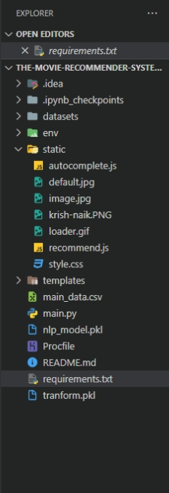

## Contents

* Datasets (folder):- Contains movie datasets from IMDB, The Movies Dataset, List of movies in 2018, List of movies in 2019, and List of movies in 2020.
* Documentations (folder):- This folder contains documentation for the project. The documentations cover the structure and overall functionality of the project. It also contains API_KEY both as text and as a screenshot.
* Screenshots (folder):- This folder has actual screenshots of the working system. It also has screenshots of the project structure.
* Static (folder):- The folder contains the webpage styling, loader GIF, background images, autocomplete code (this searches for related titles based on the searched one and gives suggestions for one to select). The files found here therefore include:
  + - autocomplete.js
    - default.jpg
    - image.jpg
    - Krish-naik.png
    - loader.gif
    - recommend.js
    - style.css
* Templates (folder):- The webpage skeletons are found here. These are used as templates to generate static websites based on the data provided. The files found here include:-
  + - home.html
    - recommend.html
* main_data.csv (file):- This provides a set of movie cast names, director names, genres, and movies related to it. This creates a comb that enables the system to create new relationships to the current data.
* main.py (file):- The file that initializes the program
* nlp_model.pkl (file)
* Procfile (file)
* README.md (file)
* requirements.txt (file)
* transform.pkl (file)

# Project Setup and Configuration

This step takes care of the project the installation and the setting up.

To start, first, do the installation of the environment and dependencies. Follow these steps:

Open up the terminal on the project folder.

Execute the following command to create the environment for the project:

python -m venv env

Once run successfully, it creates a new folder known as env which has the environment files.

Activate the environment using the following command:

./env/scripts/activate

These commands prevent the installation of the dependencies found in the requirements.txt file in the whole system especially when there is more than one project installed and set up on the computer. Doing so prevents conflicting dependencies.

Do installation of the dependencies found in the requirements.txt file by running the command below:

pip install -r requirements.txt

Wait for the full installation process which may take some time depending on the internet speed.

Make sure that the API_KEY is well set up in the recommend.js file that uses them to fetch data on the TMDB site. The API_KEY for this project created by the programmer is as seen below:

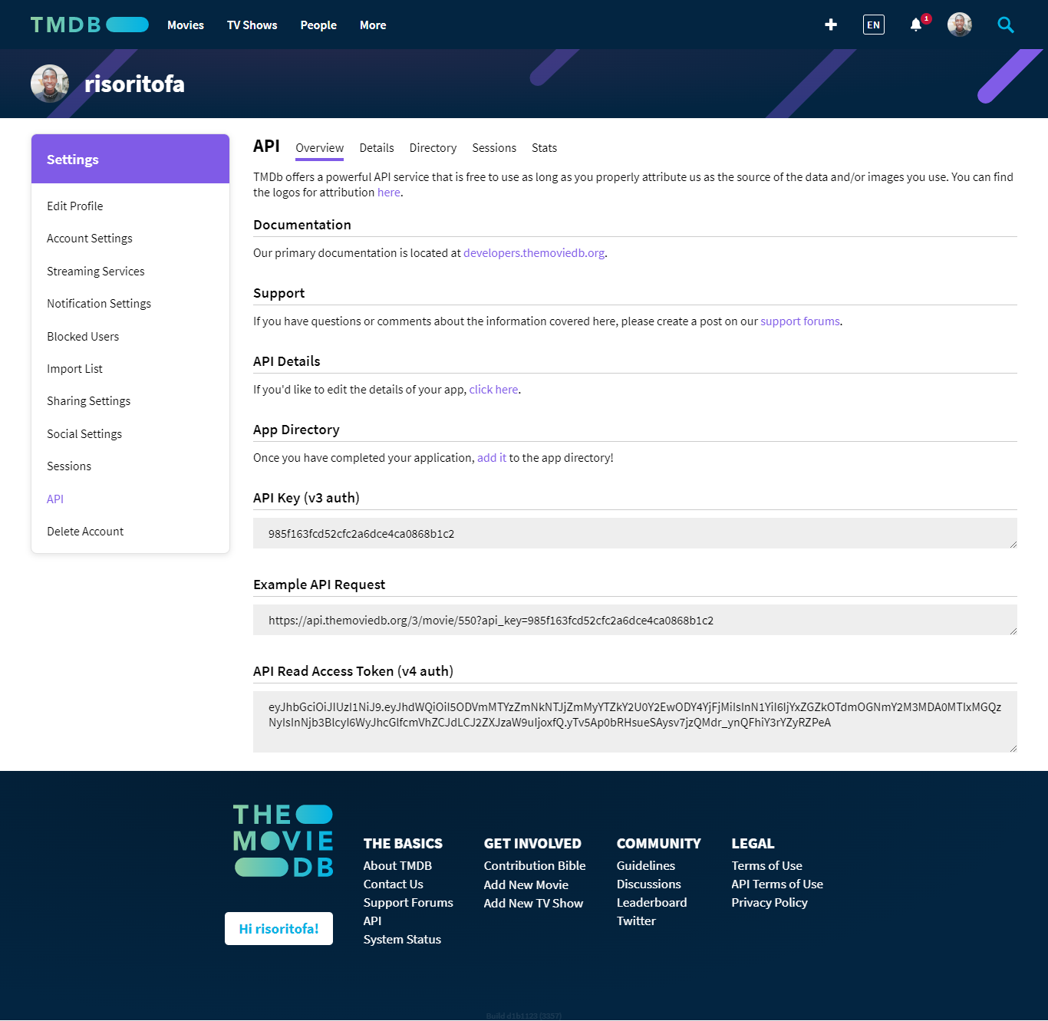

**985f163fcd52cfc2a6dce4ca0868b1c2**

The key above is already put in the project. If it’s not set up, make sure it is copied and pasted in the recommend.js file in the section represented by the API_KEY word in lines 23 and 43 of the code.

# Project Setup and Configuration Run and Access the Project

To run the project, execute the following on the terminal:

python main.py

This command runs the project via the project entry point.

Access the project via a web browser using the following URL:

<http://127.0.0.1:5000/>

# Project UI Appearance

## Main Page

The project main page (home.html) skeleton looks as follows:

The main page after successful project run, styling, and conversion into a static webpage by the framework look as shown in the image below: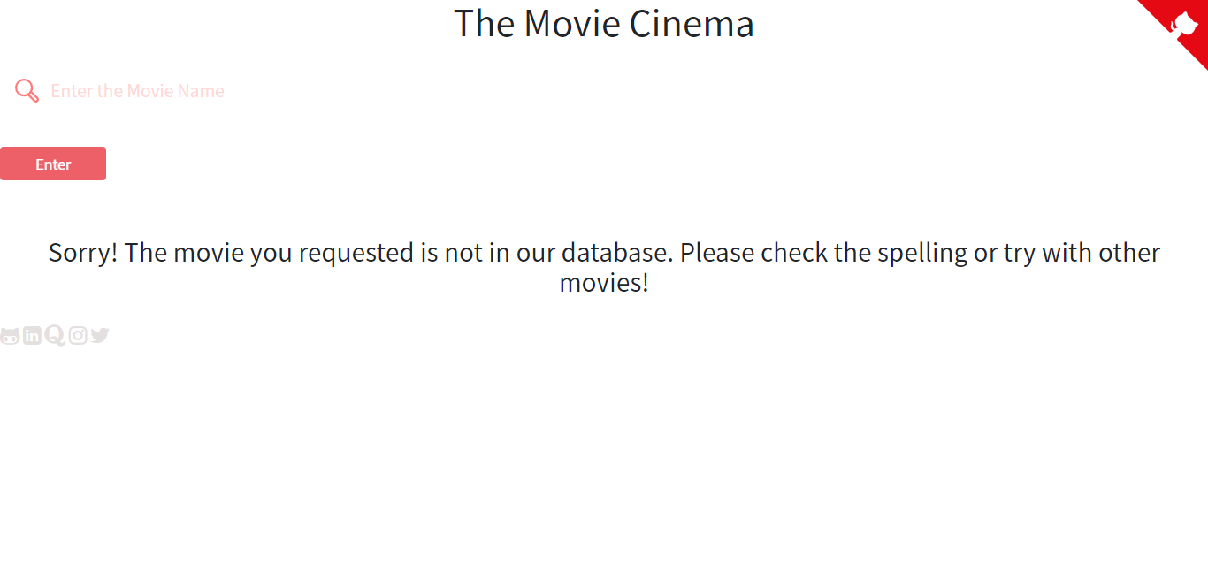

When the dialogue box is dismissed, the user is presented with the screen below where they can interact with the system.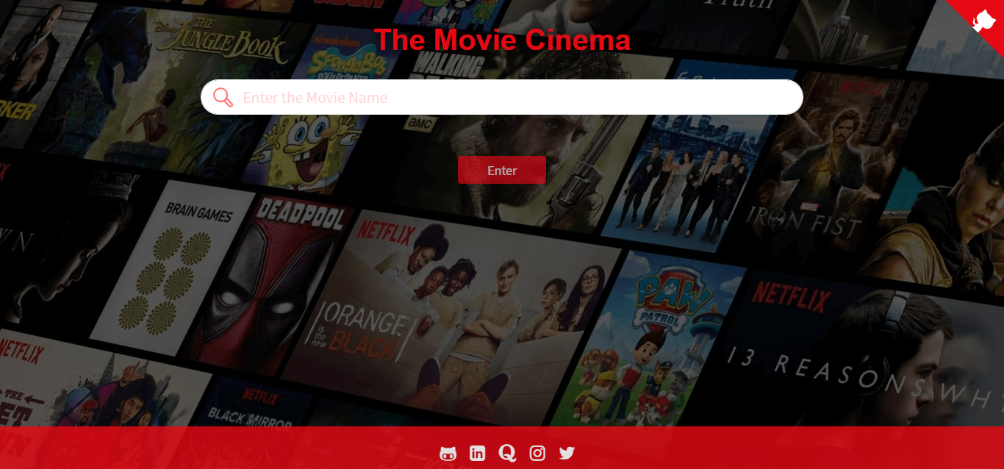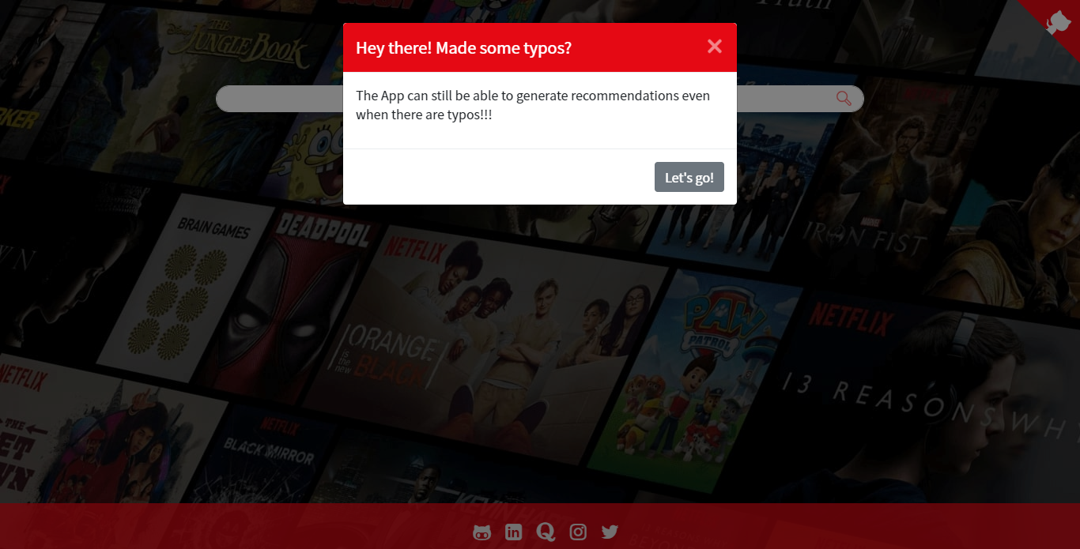

## Recommendations Webpage

The skeleton appearance of the Recommendations Webpage (recommend.html) is as follows based on its code before running the project:

Once the project is run, it uses the template above to generate a website page with the fetched data. Check it out in the image shown below: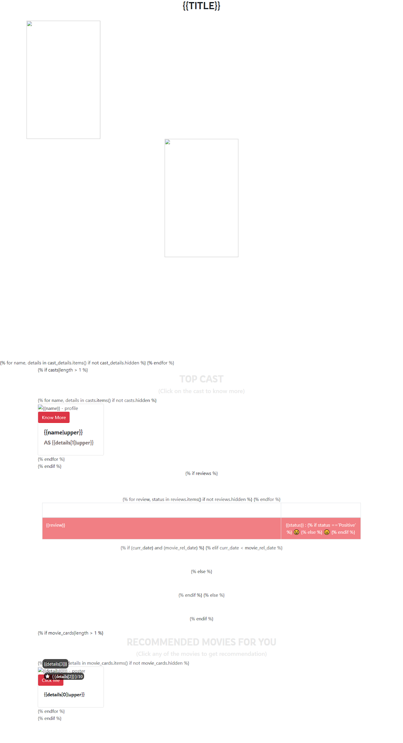

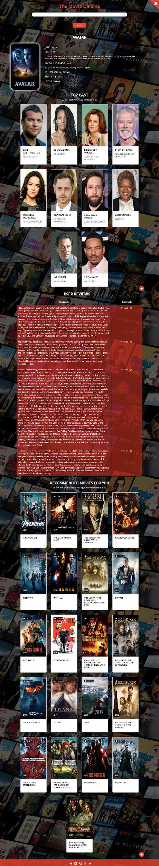

If no item is found, the following will be returned by the system:

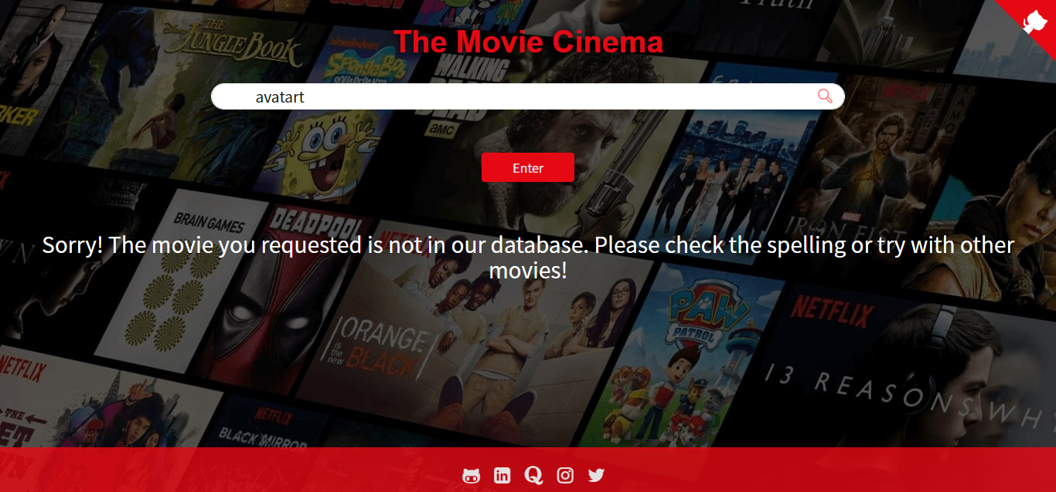

All requests are well tracked on the terminal on which the main application is executed. Open the terminal side to side with the browser and run searches. One will quickly notice that on each search, a request is displayed on the terminal. Check it out as shown in the terminal below:

This helps in monitoring the system from its deployment to its failure, hence one can know the causes of system failure.

http://127.0.0.1:5000/

It displays a webpage with a dialogue box as shown in the image below:

Dismiss the dialogue box (modal) by clicking on the close button or the ‘**Let’s go!**’ button. This action makes it display the search bar as shown below:

Click on the search bar and begin typing the name of the movie in which you want to check related recommendations to it. This step is shown below with a sample search:

Select the options autocompleted by the system based on the ones available on the data set. One can also click on the **Enter** button to perform the search. The search can be performed whether the movie being searched for is found on the data-set or not.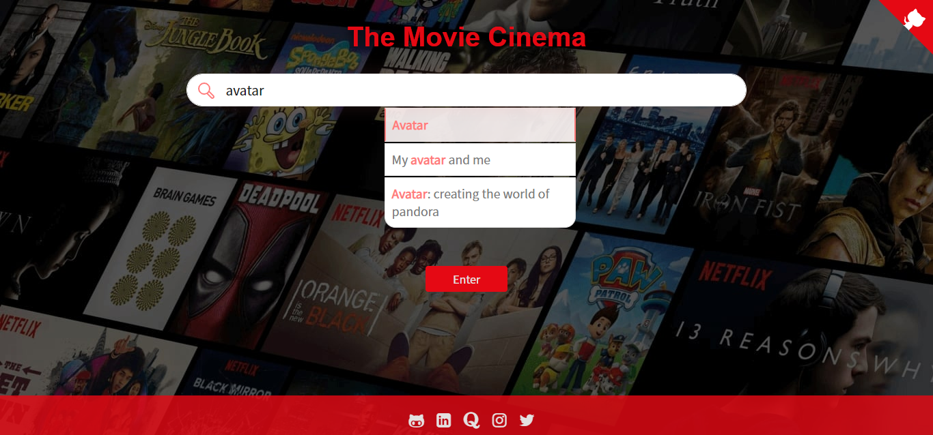

Once the search action is in execution, the program shows the loading animation as shown below:

It then displays content based on the searched-for movie. An example is shown in the image below:

In case of errors, the following will be the application response:-

This shows that the item isn’t found.

## User Interface Design

* The user interface has been designed to mainly have two pages. These are used so that the user may not need to scroll much but find all needed contents at their fingertips.
* It also has impressive colors which prevent straining while promoting consistency to the site.
* The website also has minimum features to prevent confusion and over-cramming of the contents of the site.
* The website uses input search recommendations so that it can minimize the number of errors generated. It also allows it to handle errors acceptably.

# Help and Maintenance

As for the project maintenance, the following can be performed:

1. Update the CSV file by downloading it through the following website: https://www.kaggle.com/carolzhangdc/imdb-5000-movie-dataset
2. Update the datasets found in the Dataset folder by downloading them to the following sites: <https://www.kaggle.com/carolzhangdc/imdb-5000-movie-dataset>

https://www.kaggle.com/rounakbanik/the-movies-dataset

https://en.wikipedia.org/wiki/List_of_American_films_of_2018

https://en.wikipedia.org/wiki/List_of_American_films_of_2019

<https://en.wikipedia.org/wiki/List_of_American_films_of_2020>

1. Clear the successful requests on the terminal so that it can be easy to follow up on the new ones. It also frees up the RAM for better performance of the system.
2. In case of expired API_KEY, generate a new one by visiting the official IMDB site found here: https://www.themoviedb.org/
3. Replace the old ones so that the new ones can allow one to use the application.

# References

1. The IMDB Website: <https://developer.imdb.com/>
2. TMDB Site Documentation: <https://www.themoviedb.org/documentation/api>
3. Kaggle site for free Datasets: <https://www.kaggle.com/>
4. Movie Recommender System blog by Great Learning Team: <https://www.mygreatlearning.com/blog/masterclass-on-movie-recommendation-system/>